28.56: a)
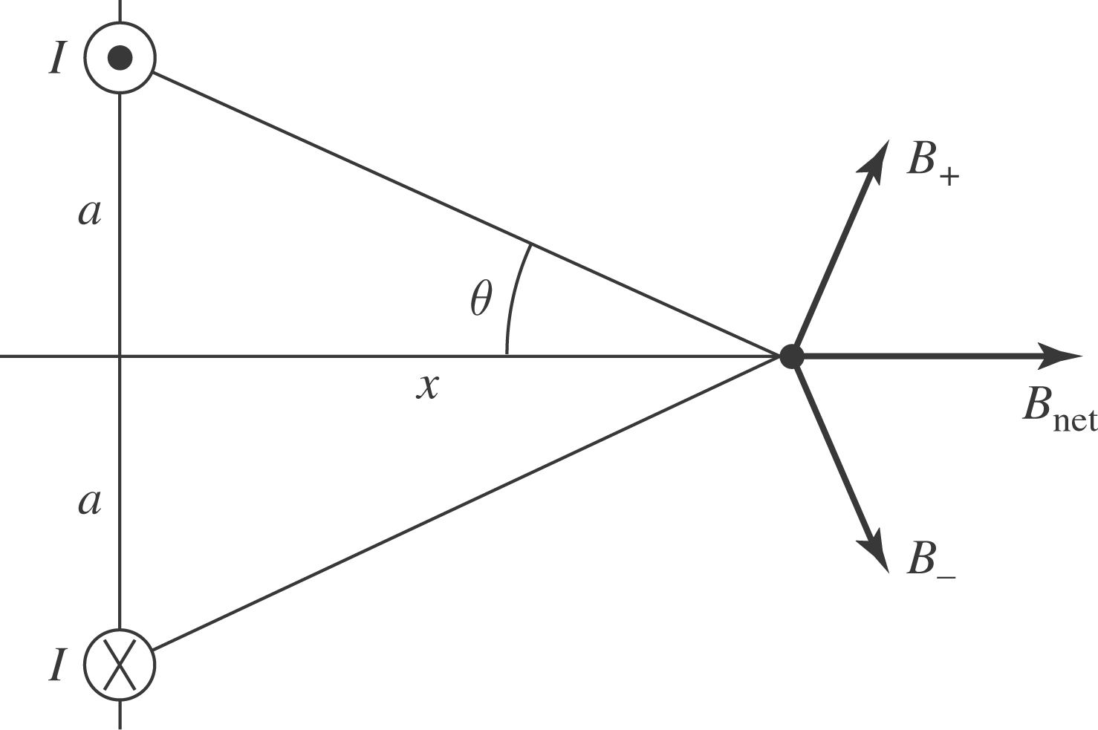
b) At a position on the x-axis:
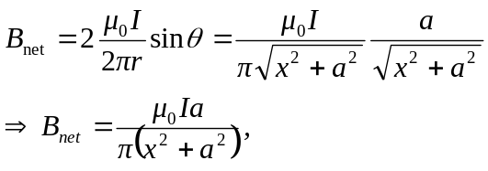
in the positive x-direction , as shown at left.
c)
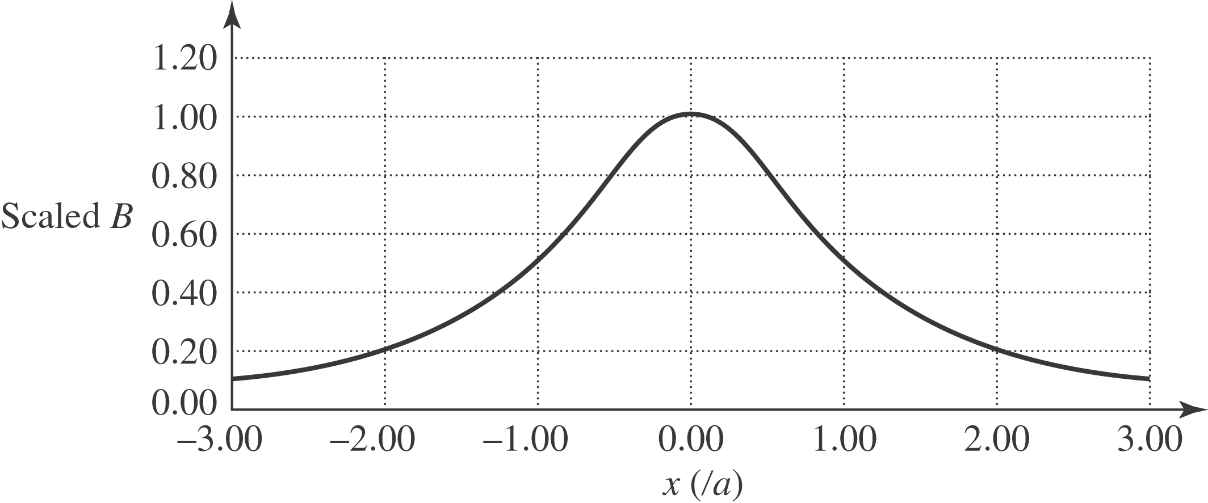
d) The magnetic field is a maximum at the origin, x = 0.
e) When 